Cement Industry Use Cases

**Preheater Cyclone Jamming**

What is the function of /Use of Preheater in cement plant?

* Preheaters are used industrial dry kiln cement production plants to heat the raw mix and drive off carbon dioxide and water before it is fed into the kiln.

What is the function of cyclone in cement plant?

* separators. significant numbers for handling high volumetric flow rates of dust-laden gases. from gas streams. Cyclones are often used as precleaners to remove more than 80% of the particles greater than 20µm in diameter.

The cyclone preheater is consist of six parts, including the upper feeding system, preheater, roller pusher, hydraulic system, lower feeding room, and etc.

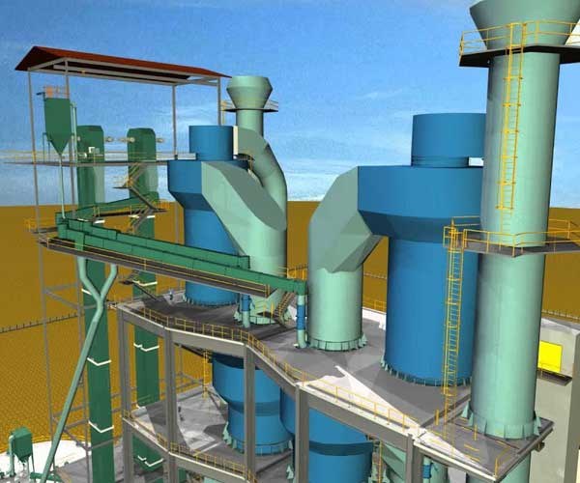

**Causes/Problem of cyclone Jamming are**:

Kiln inlet & upper part of preheater temp is high

Mismatching of kiln inlet & precalciner outlet temp

Increase recirculation of fine particles at bottom stage cyclone

In sufficient of suction due to low RPM of PH Fan

Incomplete consumption of coal

Increased recirculation of fine particles at bottom stage of cyclone

Internal circulation of volatile, So3, Cl, Alkalis in cyclone

Insufficient of suction in cyclone due to low RPM of preheater PH Fan.

Chemistry point of view:

Cl(Clorine) + Alkalis(K20,Na2O) => kcl, NaCl

Na2SO4

Factors for recirculating behavior of volatile

Sodium chloride, potassium chloride melts at 800+ deg

Calcium sulphate melts at 1450

Potassium chloride

Sodium chloride 850+

**Solution**

What are the remedial measure to avoid cyclone jamming?

1. Maintain So₃ level in Hot meal 6%, Maintain Chloride level in Hot meal 3.5%

2. Monitor & Balance Alkalis Sulphur Ratio between 0.8 to 1.2

Alkaline high, not balanced by sulphar(Free alkalin enter into kiln they chages the formation) vice versa

Solution STEPS

* Ongoing analysis of hot meal (LOI, SO3, Cl, Na2O, K2O, CaO)
* Pyro-section mass and heat balance
* Plot ongoing points on Cl-SO3 graph
* Sample the build-up material (XRF)
* Analyse Inputs-Outputs for responsible circulating element

Sulphar not combine with alkaline form solid formation which results in jamming, therefore clinker quality becomes poor and will result in cement quality reduction.

Chloride has very low melting point, which results in sticky build-up formation. Cyclone jamming

The above things will affect preheater jamming, Kiln ring formation and clinker quality reduction.

Most Import Alkaline – sulphar ratio must be balanced. To solve it component required to balance it should be added to row material.

Chloride bypass kiln inlet baghouse (Melting point, vapor pressure)

https://www.toshbrocontrols.com/industries/cement

Cooler Discharge Jamming - Chute, Hopper Jamming

Coating prevention in the burning zone

Increase in clinker temperature will result in coating formation. So it is always important to maintain equilibrium temperature in the kiln operator

Kiln speed too slow and feed loading too high in normal operation.

Excessive variations of flame temperature and length during normal operation.

Frequent changes in secondary air temperatures.

Excessive frequency of kiln-operating upsets (burning zone temperature and location varies too frequently and by too large a range).

Increased volatility of, and frequent changes in, alkali and sulfur contents in the fuel and feed.

**Refractory failure in kiln**

[**https://www.cementequipment.org/main-category/kiln-section/kiln-refractories/everything-you-need-to-know-about-cement-kiln-refractories/**](https://www.cementequipment.org/main-category/kiln-section/kiln-refractories/everything-you-need-to-know-about-cement-kiln-refractories/)

Refractory, or the lining utilized on the interior of rotary kilns, is a critical component in ensuring process efficiency and prolonging the life of a rotary kiln

Rotary kilns employ high temperatures to cause a chemical reaction or physical change in a material. In most cases, these high operating temperatures would immediately destroy an unprotected carbon steel shell. For this reason, refractory is used in Kiln.

There is two type of kiln.

 castable and brick,

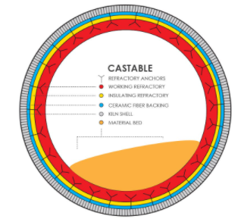 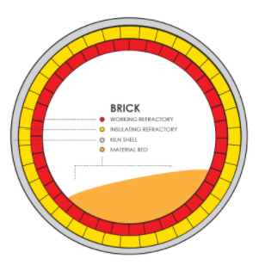

**Causes**

Cycling and chemical incompatibility are the two main causes of refractory failure in a rotary kiln.

##### **Cycling**

The biggest source of refractory failure is what is called *cycling*. Cycling is simply the heating up and cooling down of the rotary kiln. Each time the rotary kiln is heated, the refractory expands with the drum, and as the kiln is cooled, the refractory retracts. If a kiln is constantly being turned on and shut down, the refractory can easily become stressed, resulting in cracks.

Similarly, cracks can also occur from heating or cooling the kiln too quickly. To maximize refractory life, it is important to try to reduce cycling as much as possible, **keeping shut downs to a minimum.**

##### **Chemical Incompatibility**

Another common source of refractory failure is chemical incompatibility. Refractory is not designed to be able to withstand certain chemicals. A good example of this is chlorides.

Chlorides can aggressively attack refractory, causing excessive wear because of their corrosive nature. When these chemicals are identified up front, refractory can be designed with this in mind to help reduce the potential for excessive wear. Similarly, unknown components in a material or a change in feedstock can also result in excessive wear on refractory.

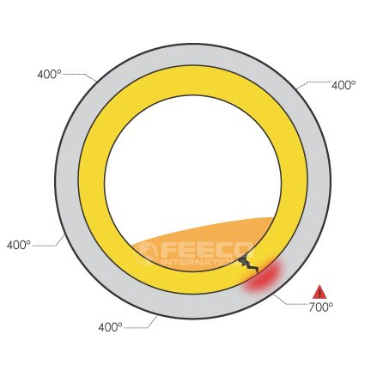

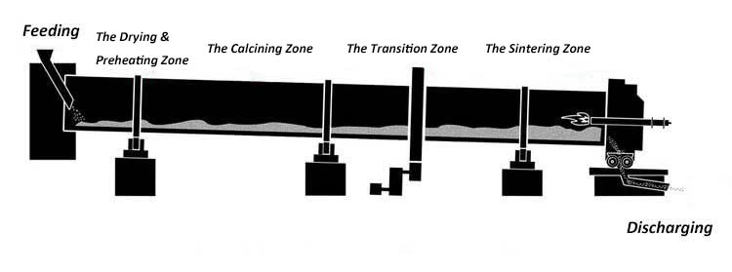

Sintering Zone - Check for leakage in steam which results in product leakage to fracture

Drying Zone - temperature maintained 200c

Firing Zone - 800c

Sintering stage: 1200oC

**Solution**

A camera set up can be used to get the scanned signal from an image. Image will have all the temperatures in the body.

Images helps us to identify body temperature.

Door not properly sealed - as a result gases flow out of the window

Choked cooling tubes inside the kiln - copper cooler gas gets chocked between the cooler and lining

Complete thinning of refractory lining -

Inside view of from kiln from exit side -

Solid ash waste at the bottom of the chimney of the kiln - Solid ash in the bottom of the chimney

<https://www.lcdri.com/news/causes-of-damage-to-refractory-lining-of-cement-rotary-kiln-and-countermeasures/>

<https://www.engineerlive.com/content/common-causes-refractory-failure>

<https://www.researchgate.net/publication/257774705_Fault_diagnosis_of_rotary_kiln_using_SVM_and_binary_ACO>

Kiln hot spot and kiln red spot - 1

Normal temperature below 500

Hot Spot - Kiln shell - Check temperature in pyrometer (High Temperature) – 570

(Red color visible during night)

Red Spot - Kiln shell - Check temperature in pyrometer (High Temperature) – 800+

We can use thermal camera system to monitor outside kiln wall.

Image processing can help to find the hot spot or red sport and can predict the maintenance for kiln coating and lining failure

Formation of Snowman in kiln

Causes – poor clinker distribution and heat exchange between clinker and secondary air

Falling down of the chute into grate cooler, freezes of the clinker liquid phase

Clinker dust carried by the secondary air stream from the clinker bed into the rotary kiln

Large lumps of coating discharge from the kiln , snowman forms when fines fall from the kiln above onto the top surface of the lumps on top of the clinker bed within the cooler.

The first two build ups are formed from small clinker nodules and clinker dust particles. Their chemical and mineralogical composition is identical to clinker, but in some cases enrichment up to 3.5 percent K20 and 3.0 percent S03 has been noticed.

high temperatures

https://www.cementequipment.org/home/snowman-formation-and-prevention/

Inlet pressure

Outlet pressure

Inletflow

Specific weight

Dust concentration

Inlet temperature

Specific heat coefficient ratio

Design temperature

ESP High Temperature

Electro static precipitation (Frees air to the atmosphere)

Standard functioning

PM10 and PM2.5

Efficiency > 99.9

Emission level <10mg/Nm3

Pressure drop<20mm WC

Gas with dust particles are passed through the esp-. it contains electrostatic energy which separates the dust from gas. The dust particles are collected using cooper and the gas is let out to atmosphere.(To reduce air pollution)

High temperature reasons:

poor combustion control

energy loss and increases flue gas volume

Ash chemistry imbalance

balance across the furnace

The effects of temperature on discharge characteristics, and dust charging characteristics are examined by using a lab-scale low-low temperature ESP setup. We find the corona current decreases and the breakdown voltage increases with the decreasing temperature. The offline dust resistivity increases and then decreases when increasing the temperature with a peak around 130-150℃. In contrast to ESP operated at 130℃, the ESP operated at 90℃ shows a remarkable improvement of dust charging distribution, especially for more residence time of particles in electric field.

The Relationship between Dust Offline Resistance and Temperature

Discharge Characteristic at Different Dust Concentration

Particle Charging Distribution at the Discharge Voltage of 18kV

Bearing Failure Detection

Vibration analysis and frequency analysis will help in detecting bearing failure

Case study:

<https://extranet.spminstrument.se/Documents/Downloads/Sales%20packages/Cement/CS_026B_Vertical_rolling_mill_HoangMai_Vn_B.pdf>

Complete cement industries guide

<https://www.eolss.net/sample-chapters/c18/E6-43-34-04.pdf>

Providing Cement industries solution

<https://dalog.net/cloud-based-maintenance-support/>

<http://knowledgeplatform.in/wp-content/uploads/2016/07/Vasavadatta-Cement-CM.pdf>

<https://www.spminstrument.com/measuring-techniques>